2nd Order Butterworth
3500 Hertz
8 Ohm Tweeter / 4 Ohm Woofer
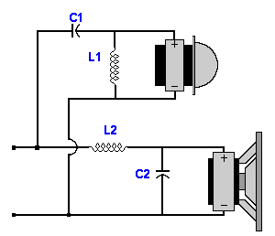 | Parts List  Capacitors  C1 = 4.02 uF  C2 = 8.04 uF  Inductors  L1 = 0.51 mH  L2 = 0.26 mH

